Organic Staple Crop Buyers
The growth for organic grain has resulted in a network of grain merchants and end-users with the desire to purchase organic crops across the corn belt. Below is a partial list of companies with competitive bids for corn, soybeans, wheat, and other crops.

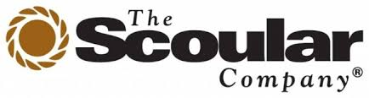
Dustin Ploeger – organic buyer
13660 California St
omaha NE 68154
402 449 1499

 | Anders Gurda  Director – Farm Profit Program  Cell: 612-868-1208  agurda@pipelinefoods.com  www.pipelinefoods.com | 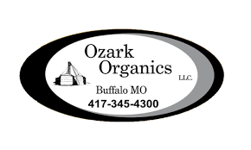
 | 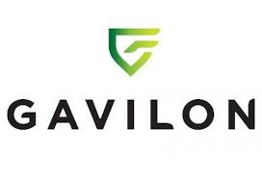 | 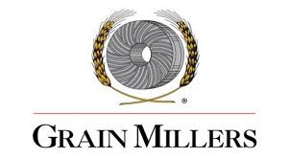
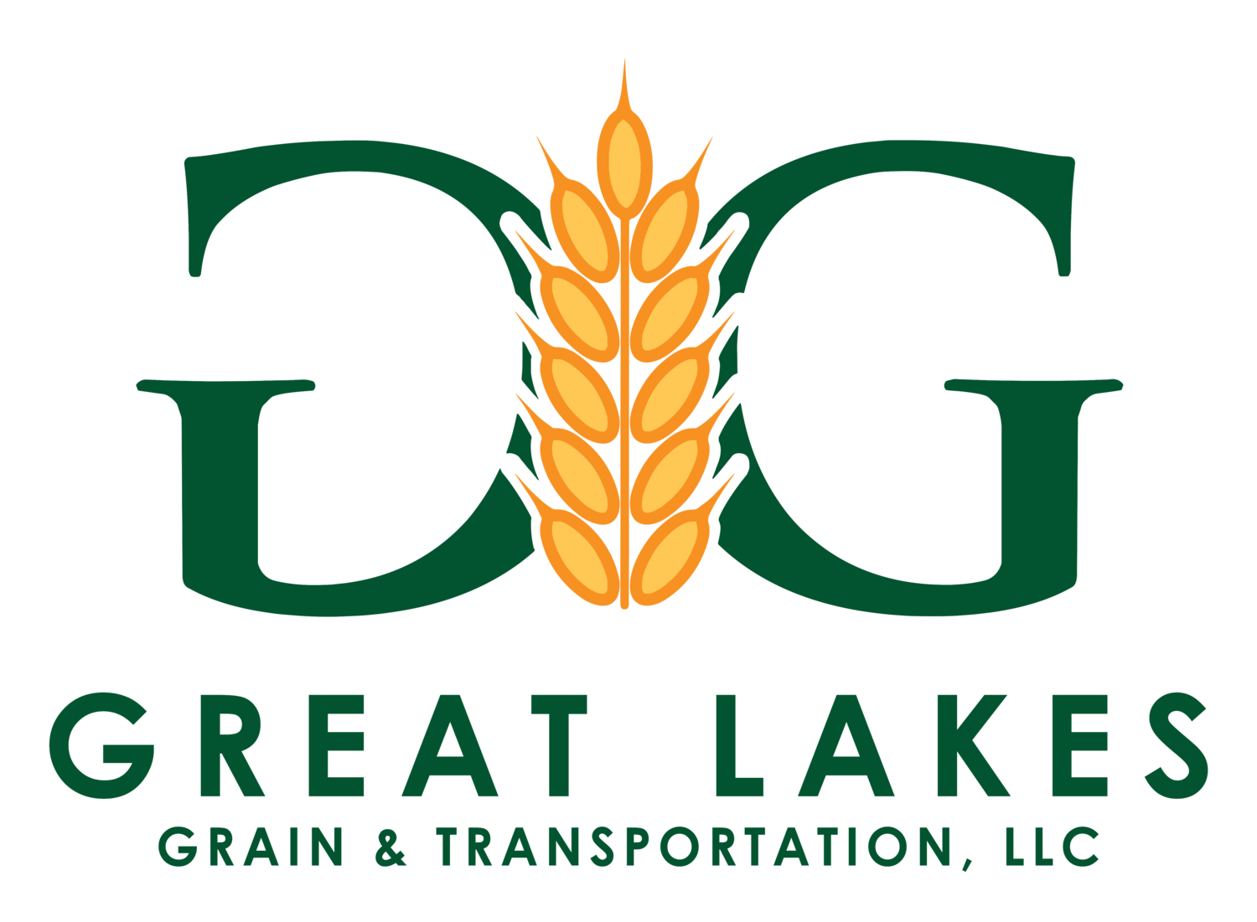 | 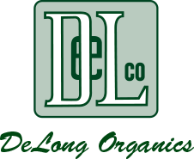 | 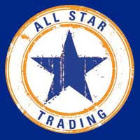
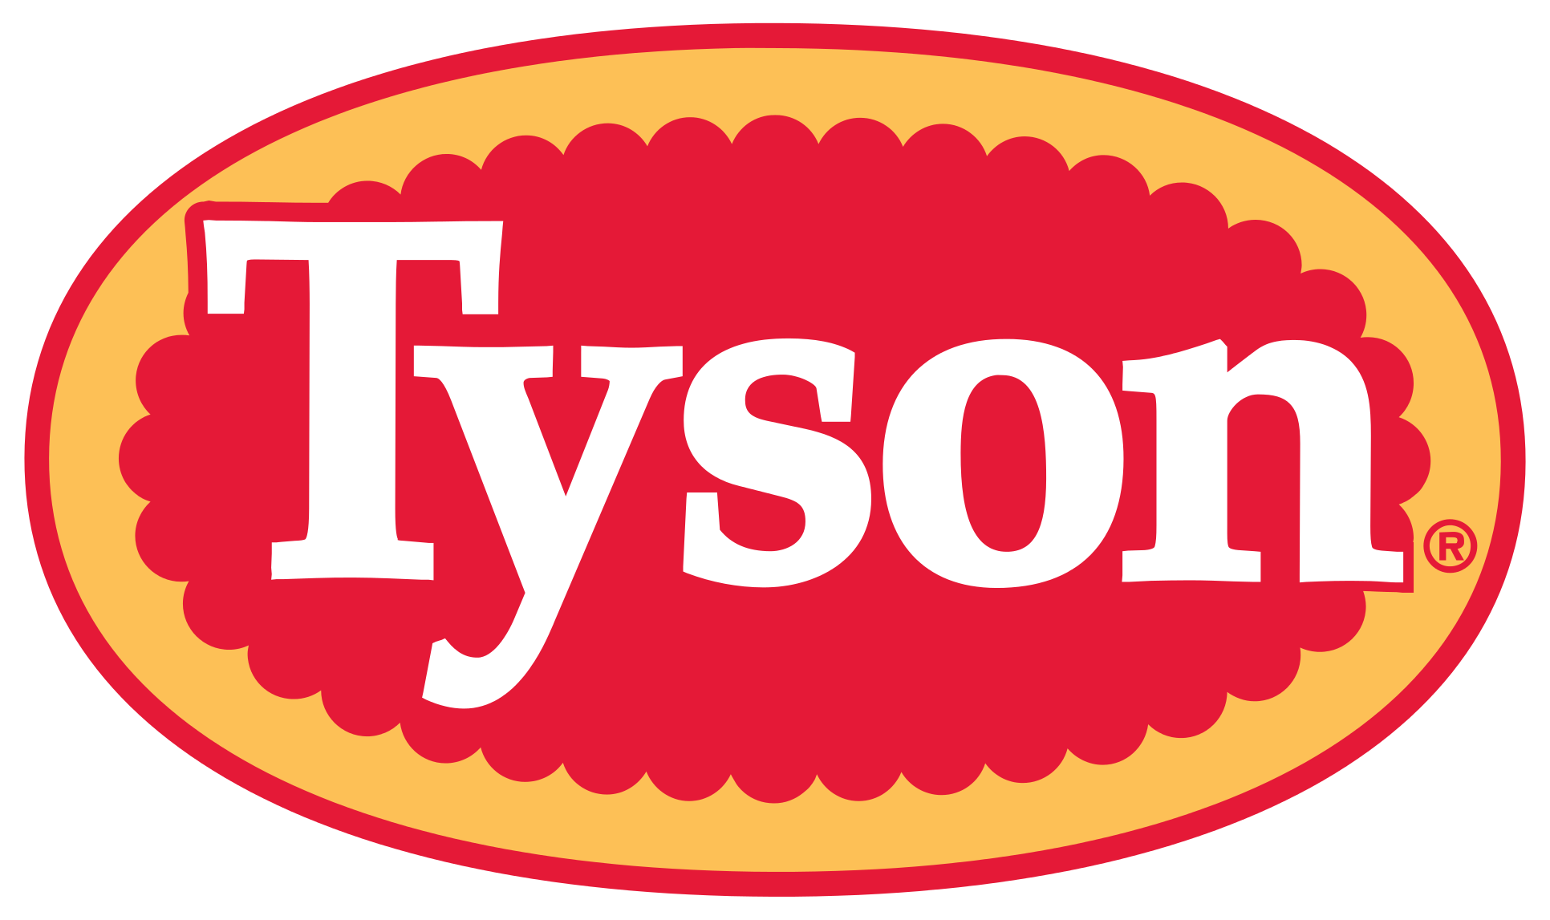 | 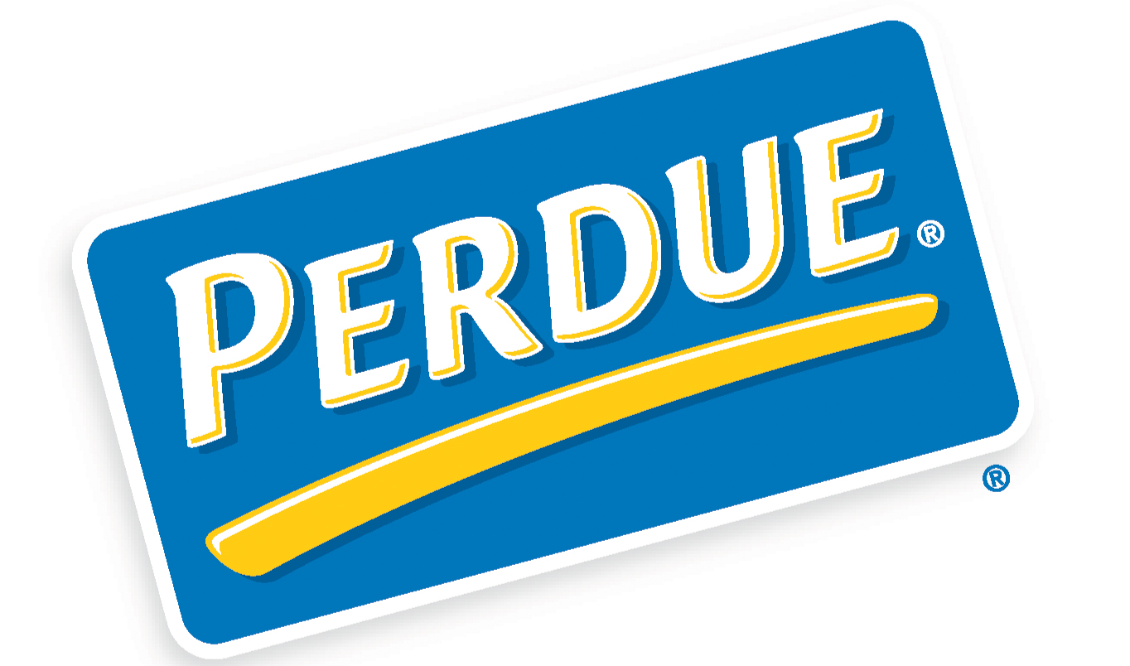

Others to Try:

Brent Shaffner
Purchasing Agent #1
Healthy Food Ingredients
d: 605-884-1124 | c: 605-759-1637
HFIfamily.com

Matt Nidlinger
Consolidated Grain and Barge Co.
5130 Port Road, Jeffersonville, IN 47130 | www.cgb.com
Office 812.218.6775 Mobile 260.438.2590

From OGRAIN ORGANIC GRAIN RESOURCE LIST

BUYERS AND BROKERS
Ag Motion Specialty Grains
612-486-3800, 720 2nd Ave., S. Ste 700, Minneapolis, MN 55402
Commodity trading of organic corn, soybeans and small grains.
All Star Trading
847-375-8675, 2100 Clearwater Dr., Suite 320, Oak Brook, IL 60523
Feed ingredient merchants of organic grains, corn, beans.
Briess Malt and Ingredients Co.
920-849-7711, 625 Irish Rd., Chilton, WI 53014
Purchasing of organic barley, corn and other small grains.
Buckwheat Growers Association of MN
218-631-9212, 206 Aldrich Ave., SE, Wadena, MN 56482
Farmer owned coop for buckwheat and other grains.
Cashton Farm Supply
608-654-5123, 300 WI Hwy 27, Cashton, WI 54619
Organic feed manufacturing and distribution, along with organic custom pullet raising, poultry equipment sales and organic seed sales.
Chippewa Valley Bean Co. Inc,
715-664-8342, N2960 730th St., Menomonie, WI 54751
Providing superior kidney bean quality by using natural, non-GMO technology and stringent growing and harvesting practices.
Clarkson Grain
217-763-2861, 320 East South St., Cerro Gordo, IL 61818
Producing identity preserved non-GMO and organic corn and soybeans for food ingredients.
Dahlgren and Company
218-281-2985, 1220 Sunflower St., Crookston, MN 56716
Buyer of sunflower seeds for processing, sunflower seed provider.
DeLong Company
1313 S. Colony Ave., Union Grove, WI 53182
Grain elevator and major supplier of food grains, also providing seed, fertilizer and chemical inputs and services for growers in Wisconsin and Illinois.
Everbest Organics
989-659-2599, 136 East Munger Rd., Munger MI 48747
Contracting for organic soybeans, edible beans and small grains.
FW Cobs
888-531-4888, PO Box 30, Saint Albans Bay, VT 05481
Organic grains and beans bought and sold across U.S. and Canada.
Grain Millers
800-328-5188
Leading manufacturer of conventional and organic whole grain ingredients used in cereals, breads, bars and many other products. Grains include oats, wheat, barley and rye, milled into flours, flakes, brans and fibers.
Grain Place Foods
1904 North Hwy 14, Marquette, NE 68854
Organic and non-GMO barley, corn, flax, kamut, millet, oats, popcorn, quinoa, rye, soybeans, spelt, sunflower, triticale, wheat.
Grass and Sons Seed
507-324-5820, 77249 125th St., LeRoy, MN 55951
Buying and cleaning organic and non-GMO corn, soybeans, small grains.
Herbrucks- Great Lakes Organic Feed Mill
616-642-0824, 248 West Portland Rd., Lake Odessa, MI 48849
Buying organic corn, soybeans grains, selling organic livestock feed and pelleted or bulk chicken manure.

Indigo Ag
844-828-0240, 500 Rutherford Avenue Boston, MA 02129
Buyers and sellers of organic grain, testing and transportation

Jaco Commodities LLC
712-395-3060, 4695 US 75 Ave, Maurice, Iowa 51036
An “Integrity Based” company supplying a wide range of organic and conventional grains, including pulses (peas, beans, lentils) and various feed grains to both domestic and export customers.

La Crosse Milling
608-248-2222, 101 WI-35 Cochrane, WI 54622
Specialty grain manufacturer of organic oat products

Langeland Farms
3806 South County Rd. 550, East Greensburg, IN 47240
Organic and non-GMO food and feed grade soybeans, dry beans (black turtle and other), wheat, spelt, oats, barley, rye, popcorn, yellow corn.

Lonesome Stone Milling
608-583-2100, 304 South Oak Street Lone Rock, WI 53556
Flour mill purchasing locally grown organic small grains

Madison Sourdough Co.
608-442-8007, 916 Williamson St., Madison, WI 53703
A modern communal oven bakery and patisserie specializing in naturally leavened, (sourdough), breads using Wisconsin grown wheat, rye, and corn milled in an Austrian stone mill.
Midwest Organic Farmers Co-op
217-745-2500, 317 Sciota St, Sibley, IL 61773
Certified organic and transitional feed for lambs, chickens, goats, turkeys, ducks, chicks, pigs & more.

Natural Products Inc.
641-236-0852, 2211 6th Ave., Grinnell, IA 50112
Buyers of organic soybeans.

Natural Way Mills
218-222-3677, 24509 390th Street NE Middle River, MN 56737 naturalwaymills@wiktel.com
Organic grains, flours, cereals and legumes

Nature’s Organic Grist
763-795-0042, 20405 Everton Tr. North Forest Lake, MN 55025
Organic ancient grains, cereal grains, pulses, seeds, feeds and food grade flours

NForganics
800-247-2110, P.O. Box 2508, Ames, IA 50010
Brokers and buyers of high quality organic grains.
OFARM
715-467-0031, PO Box 133, Aldrich, MN 56434
Coordinator of organic producer marketing groups.

Organic Grain Exchange
On-line “auction” platform for buying and selling organic commodities, linking sellers with buyers. No listing fees.

Organic Valley
888-809-9297, One Organic Way, La Farge, WI 54639
The nation’s largest farmer-owned organic cooperative, and one of the worlds’ largest organic consumer brands. With over 2,000 members around the U.S. producing organic milk, egg, meat, soy, produce, and livestock feed.
Pipeline Foods
763-999-7720, 1250 East Moore Lake Dr. Suite 200, Minneapolis, MN 55432
A supply chain solutions company focused exclusively on non-GMO and organic food and feed.
Plovgh
877-567-1678, PO Box 295, Viroqua, Wisconsin 54665
A boutique grain company handling source- and variety-specific grains, primarily organic and transitional. Their signature crops are perennial grains like Kernza, specialty ryes, and unique barley and wheat varieties.Distributor for Albert Lea Seeds.
Professional Proteins Ltd
319-653-6541, 2346 Highway 1 and 92, Washington, IA 52353
Non-GMO and organic soybean products and livestock feeds.
Puris
612-400 1420, 811 Glenwood Ave., Minneapolis, MN 55405
Organic and non-GMO corn, soybean, peas.
Red River Commodities
800-437-5539, PO Box 3022, Fargo, ND 58108
Trading of sunflower seeds, flax and millet.
Richland IFC, Inc.
218-643-1797, 100 10th St. North, Breckenridge, MN 56520
Organic and non-GMO specialty soybeans and corn.
Rovay Seed Company
217-227-4541, 1157 Rovey Ave., Farmerville, IL 62533
Organic and non-GMO white, yellow, blue and red corn.
Scoular Company
2027 Dodge St., Omaha, NE 68102
Organic and non-GMO corn, soybeans, wheat, sorghum, millet, oats, barley, popcorn, flax, dry beans, peas, lentils.
Soyko International
800-245-1638, 2493 380th St., Gary, MN 56545
Organic and non-GMO soybeans, corn, wheat, barley.
Stonebridge, Ltd
319-277-4277, 3411 Midway Dr., Cedar Falls, IA 50613
Organic and non-GMO soybeans, soybean seed and meal (food and feed grades), corn (food and feed grades).
SunOpta Inc.
952-820-2518, 7301 Ohms Lane Ste 600, Edina, MN 55439
Organic and non-GMO soybeans, corn, sunflower, beans and more.

Sunrise Foods International
306-986-0033, 715 South 4th Street, Pender, NE 68047
Buying and selling organic and conventional grain and feed. Handling the details of logistics, processing and quality assurance from your bin to the customer’s door.

Comprehensive List from Albert Lea Seed by State:

Non-GMO & Organic Grain & Corn Buyers | Albert Lea Seed (alseed.com)

